Windows平台下的MathAI配置

--oruizn(著)

**1、新建一个项目,自动建好虚拟环境（第1、2步骤可以颠倒）**

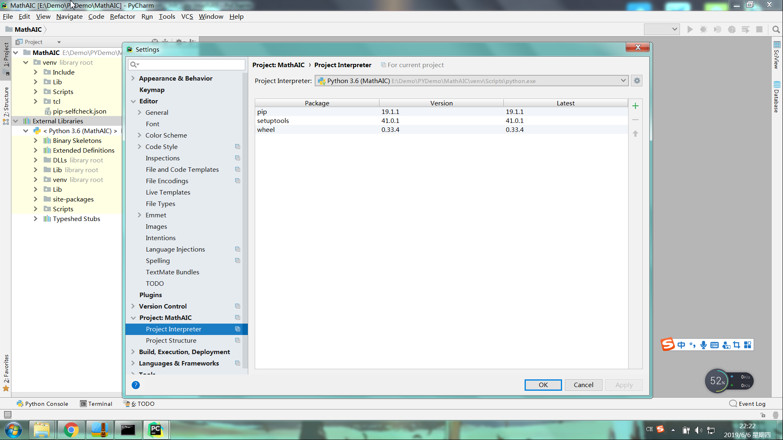

**2、把源码放进项目文件夹中**

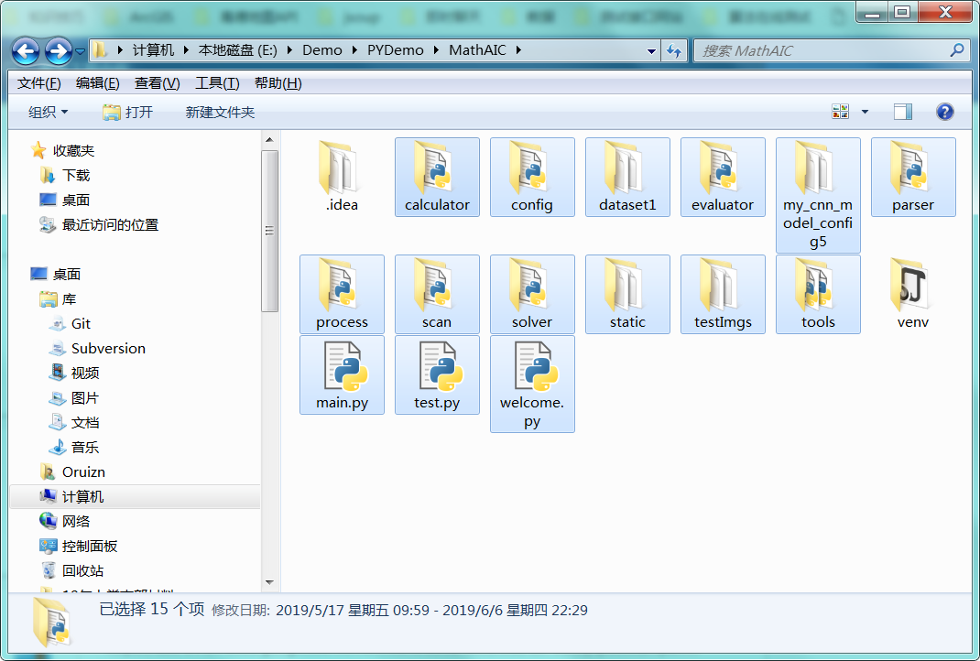

**3、设置启动文件**

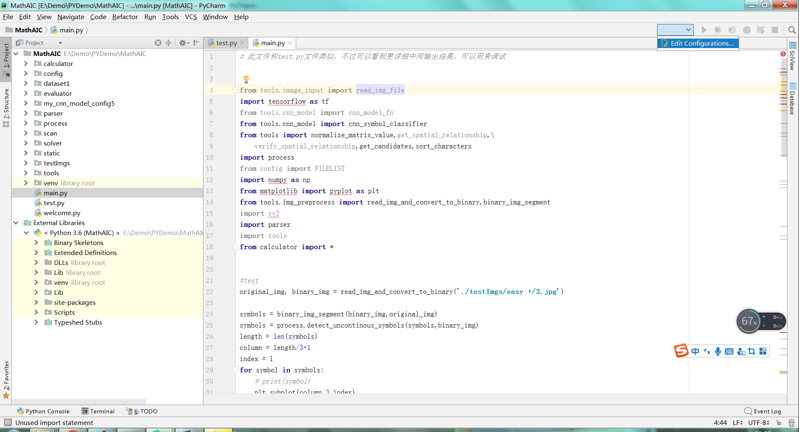

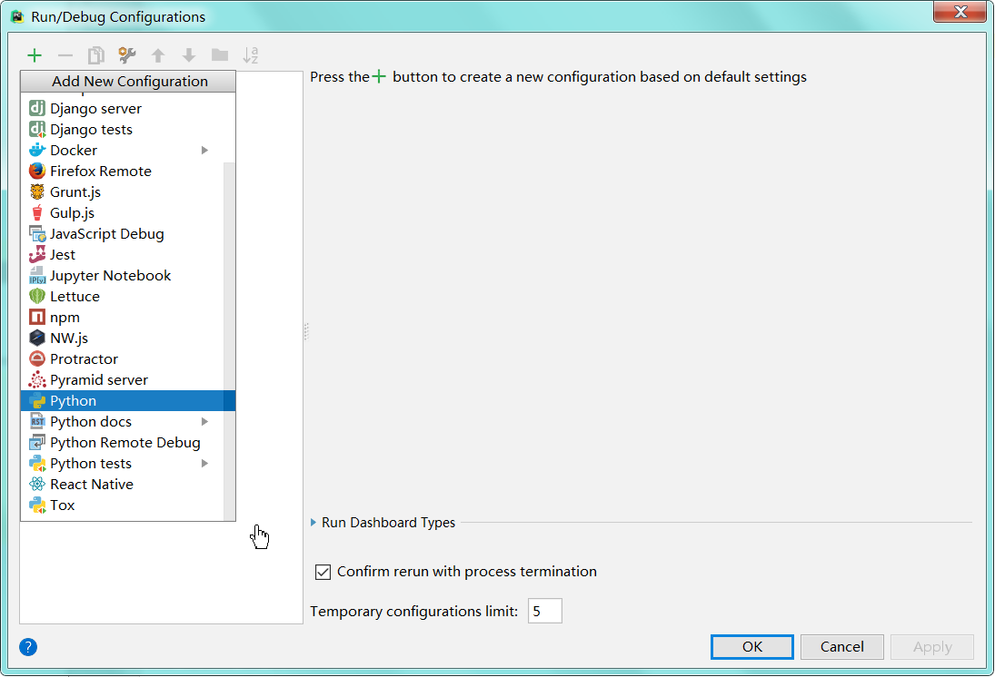

**4、启动项目后（main），无法运行。（由于缺少必要的库）**

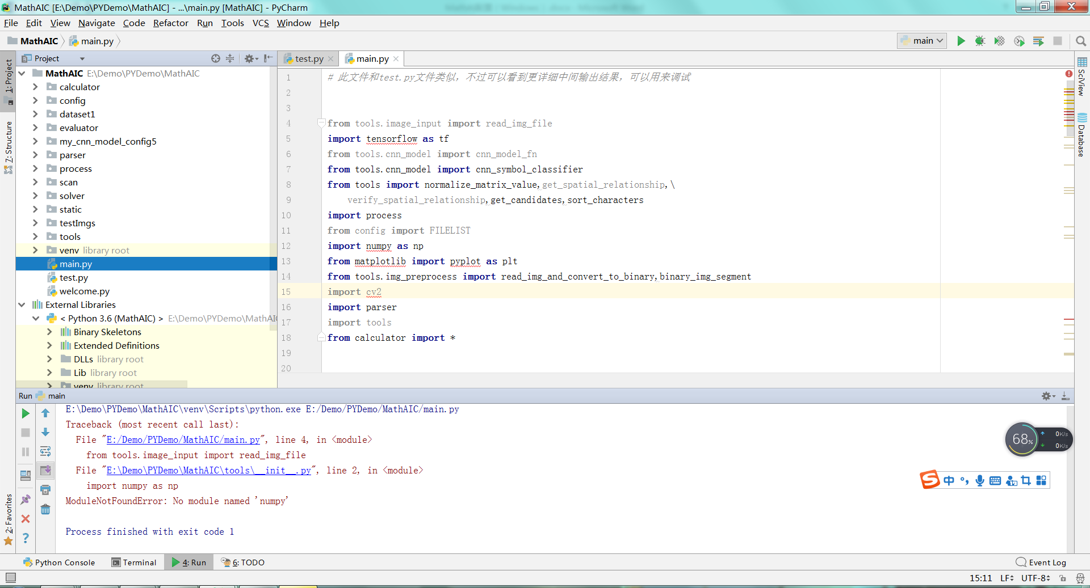

**5、添加对应的库**

点击进入Terminal界面

cd进入pip程序所在的文件夹：

**cd venv/Scripts**



开始安装需要的库

**pip install numpy**

**pip install tensorflow==**1.13.1

**pip install opencv-python==3.4.0.12（由于其中一个函数限制，4.0.0以上版本报错）**

**pip install matplotlib==3.0.3（与其他库冲突，经测试后3.0.3不会报错）**

**pip install scipy**

**pip install scikit-image**

**pip install sympy**

**pip install flask**

【以下为安装信息】

(venv) E:\Demo\PYDemo\MathAIC\venv\Scripts>**pip install numpy**

Collecting numpy

Using cached https://files.pythonhosted.org/packages/20/ed/e036d31a9b2c750f270cbb1cfc1c0f94ac78ae504eea7eec3267be4e294a/numpy-1.16.4-cp36-cp36m-win_amd64.whl

Installing collected packages: numpy

Successfully installed numpy-1.16.4

(venv) E:\Demo\PYDemo\MathAIC\venv\Scripts>**pip install tensorflow**

Collecting tensorflow

Using cached https://files.pythonhosted.org/packages/bf/58/34bfa8fa17f86333361172b3b502e805195180f19a7496ad0f6149138d55/tensorflow-1.13.1-cp36-cp36m-win_amd64.whl

Requirement already satisfied: wheel>=0.26 in e:\demo\pydemo\mathaic\venv\lib\site-packages (from tensorflow) (0.33.4)

Collecting astor>=0.6.0 (from tensorflow)

Using cached https://files.pythonhosted.org/packages/d1/4f/950dfae467b384fc96bc6469de25d832534f6b4441033c39f914efd13418/astor-0.8.0-py2.py3-none-any.whl

Collecting gast>=0.2.0 (from tensorflow)

Collecting tensorflow-estimator<1.14.0rc0,>=1.13.0 (from tensorflow)

Using cached https://files.pythonhosted.org/packages/bb/48/13f49fc3fa0fdf916aa1419013bb8f2ad09674c275b4046d5ee669a46873/tensorflow_estimator-1.13.0-py2.py3-none-any.whl

Collecting keras-preprocessing>=1.0.5 (from tensorflow)

Using cached https://files.pythonhosted.org/packages/28/6a/8c1f62c37212d9fc441a7e26736df51ce6f0e38455816445471f10da4f0a/Keras_Preprocessing-1.1.0-py2.py3-none-any.whl

Collecting six>=1.10.0 (from tensorflow)

WARNING: Retrying (Retry(total=4, connect=None, read=None, redirect=None, status=None)) after connection broken by 'ReadTimeoutError("HTTPSConnectionPool(host='pypi.org', port=443): Read timed out. (

read timeout=15)",)': /simple/six/

Using cached https://files.pythonhosted.org/packages/73/fb/00a976f728d0d1fecfe898238ce23f502a721c0ac0ecfedb80e0d88c64e9/six-1.12.0-py2.py3-none-any.whl

Requirement already satisfied: numpy>=1.13.3 in e:\demo\pydemo\mathaic\venv\lib\site-packages (from tensorflow) (1.16.4)

Collecting keras-applications>=1.0.6 (from tensorflow)

Using cached https://files.pythonhosted.org/packages/71/e3/19762fdfc62877ae9102edf6342d71b28fbfd9dea3d2f96a882ce099b03f/Keras_Applications-1.0.8-py3-none-any.whl

Collecting tensorboard<1.14.0,>=1.13.0 (from tensorflow)

Using cached https://files.pythonhosted.org/packages/0f/39/bdd75b08a6fba41f098b6cb091b9e8c7a80e1b4d679a581a0ccd17b10373/tensorboard-1.13.1-py3-none-any.whl

Collecting termcolor>=1.1.0 (from tensorflow)

Collecting protobuf>=3.6.1 (from tensorflow)

Using cached https://files.pythonhosted.org/packages/d4/59/ec6c6075dd628f2efd33dbe11b259e63e1de7cbc26e45b38de767df528d4/protobuf-3.8.0-cp36-cp36m-win_amd64.whl

Collecting grpcio>=1.8.6 (from tensorflow)

Using cached https://files.pythonhosted.org/packages/4c/6a/e83233ed636bdf8668f0e79897fd70bce04869482dd88f3cfc4c42404fb2/grpcio-1.21.1-cp36-cp36m-win_amd64.whl

Collecting absl-py>=0.1.6 (from tensorflow)

Collecting mock>=2.0.0 (from tensorflow-estimator<1.14.0rc0,>=1.13.0->tensorflow)

Using cached https://files.pythonhosted.org/packages/05/d2/f94e68be6b17f46d2c353564da56e6fb89ef09faeeff3313a046cb810ca9/mock-3.0.5-py2.py3-none-any.whl

Collecting h5py (from keras-applications>=1.0.6->tensorflow)

Using cached https://files.pythonhosted.org/packages/01/1e/115c4403544a91001d9c618748b2e8786db45544e36b8a6cf3c525e9b57f/h5py-2.9.0-cp36-cp36m-win_amd64.whl

Collecting markdown>=2.6.8 (from tensorboard<1.14.0,>=1.13.0->tensorflow)

Using cached https://files.pythonhosted.org/packages/c0/4e/fd492e91abdc2d2fcb70ef453064d980688762079397f779758e055f6575/Markdown-3.1.1-py2.py3-none-any.whl

Collecting werkzeug>=0.11.15 (from tensorboard<1.14.0,>=1.13.0->tensorflow)

Using cached https://files.pythonhosted.org/packages/9f/57/92a497e38161ce40606c27a86759c6b92dd34fcdb33f64171ec559257c02/Werkzeug-0.15.4-py2.py3-none-any.whl

Requirement already satisfied: setuptools in e:\demo\pydemo\mathaic\venv\lib\site-packages (from protobuf>=3.6.1->tensorflow) (41.0.1)

Installing collected packages: astor, gast, six, mock, absl-py, tensorflow-estimator, keras-preprocessing, h5py, keras-applications, grpcio, markdown, werkzeug, protobuf, tensorboard, termcolor, tensor

flow

Successfully installed absl-py-0.7.1 astor-0.8.0 gast-0.2.2 grpcio-1.21.1 h5py-2.9.0 keras-applications-1.0.8 keras-preprocessing-1.1.0 markdown-3.1.1 mock-3.0.5 protobuf-3.8.0 six-1.12.0 tensorboard-1

.13.1 tensorflow-1.13.1 tensorflow-estimator-1.13.0 termcolor-1.1.0 werkzeug-0.15.4

(venv) E:\Demo\PYDemo\MathAIC\venv\Scripts>**pip install opencv -python==3.4.0.12**

Collecting opencv-python==3.4.0.12

Downloading https://files.pythonhosted.org/packages/4c/25/151aeb11e80f99b97d3eb93a2c98bcacd857f28c4fb8865eb0201d800e97/opencv_python-3.4.0.12-cp36-cp36m-win_amd64.whl (33.3MB)

|████████████████████████████████| 33.4MB 273kB/s

Requirement already satisfied: numpy>=1.11.3 in e:\demo\pydemo\mathaic\venv\lib\site-packages (from opencv-python==3.4.0.12) (1.16.4)

Installing collected packages: opencv-python

Successfully installed opencv-python-3.4.0.12

(venv) E:\Demo\PYDemo\MathAIC\venv\Scripts>**pip install matplotlib==3.0.3**

Collecting matplotlib==3.0.3

Using cached https://files.pythonhosted.org/packages/21/4c/35fa1837a705f33621604a1967b1505bd3f695940fdf02fad77ef11de196/matplotlib-3.0.3-cp36-cp36m-win_amd64.whl

Collecting python-dateutil>=2.1 (from matplotlib==3.0.3)

Using cached https://files.pythonhosted.org/packages/41/17/c62faccbfbd163c7f57f3844689e3a78bae1f403648a6afb1d0866d87fbb/python_dateutil-2.8.0-py2.py3-none-any.whl

Collecting kiwisolver>=1.0.1 (from matplotlib==3.0.3)

Using cached https://files.pythonhosted.org/packages/64/46/75ab48386cbd56065f5542360562be524ad599911455b6d95520cb118613/kiwisolver-1.1.0-cp36-none-win_amd64.whl

Requirement already satisfied: numpy>=1.10.0 in e:\demo\pydemo\mathaic\venv\lib\site-packages (from matplotlib==3.0.3) (1.16.4)

Collecting pyparsing!=2.0.4,!=2.1.2,!=2.1.6,>=2.0.1 (from matplotlib==3.0.3)

Using cached https://files.pythonhosted.org/packages/dd/d9/3ec19e966301a6e25769976999bd7bbe552016f0d32b577dc9d63d2e0c49/pyparsing-2.4.0-py2.py3-none-any.whl

Collecting cycler>=0.10 (from matplotlib==3.0.3)

Using cached https://files.pythonhosted.org/packages/f7/d2/e07d3ebb2bd7af696440ce7e754c59dd546ffe1bbe732c8ab68b9c834e61/cycler-0.10.0-py2.py3-none-any.whl

Requirement already satisfied: six>=1.5 in e:\demo\pydemo\mathaic\venv\lib\site-packages (from python-dateutil>=2.1->matplotlib==3.0.3) (1.12.0)

Requirement already satisfied: setuptools in e:\demo\pydemo\mathaic\venv\lib\site-packages (from kiwisolver>=1.0.1->matplotlib==3.0.3) (41.0.1)

Installing collected packages: python-dateutil, kiwisolver, pyparsing, cycler, matplotlib

Successfully installed cycler-0.10.0 kiwisolver-1.1.0 matplotlib-3.0.3 pyparsing-2.4.0 python-dateutil-2.8.0

(venv) E:\Demo\PYDemo\MathAIC\venv\Scripts>**pip install scipy**

Collecting scipy

Using cached https://files.pythonhosted.org/packages/9e/fd/9a995b7fc18c6c17ce570b3cfdabffbd2718e4f1830e94777c4fd66e1179/scipy-1.3.0-cp36-cp36m-win_amd64.whl

ERROR: Operation cancelled by user

(venv) E:\Demo\PYDemo\MathAIC\venv\Scripts>pip install scipy

Collecting scipy

Using cached https://files.pythonhosted.org/packages/9e/fd/9a995b7fc18c6c17ce570b3cfdabffbd2718e4f1830e94777c4fd66e1179/scipy-1.3.0-cp36-cp36m-win_amd64.whl

Requirement already satisfied: numpy>=1.13.3 in e:\demo\pydemo\mathaic\venv\lib\site-packages (from scipy) (1.16.4)

Installing collected packages: scipy

Successfully installed scipy-1.3.0

(venv) E:\Demo\PYDemo\MathAIC\venv\Scripts>**pip install scikit-image**

Collecting scikit-image

Using cached https://files.pythonhosted.org/packages/24/d5/a016b686ba4030c7e6039033bef899ff8a790819479016b2365eb929eacc/scikit_image-0.15.0-cp36-none-win_amd64.whl

Collecting PyWavelets>=0.4.0 (from scikit-image)

Using cached https://files.pythonhosted.org/packages/d9/98/2e0af756fa7c1bb49f752078c3e5c1dbf0d98b800c0a9c6f37d7a5cef2ef/PyWavelets-1.0.3-cp36-none-win_amd64.whl

Collecting imageio>=2.0.1 (from scikit-image)

Using cached https://files.pythonhosted.org/packages/af/0a/943c965d372dae0b1f1482677d29030ab834351a61a9a632fd62f27f1523/imageio-2.5.0-py3-none-any.whl

Collecting networkx>=2.0 (from scikit-image)

Collecting pillow>=4.3.0 (from scikit-image)

Using cached https://files.pythonhosted.org/packages/e6/37/fc5bde88462cf8a069e522dd6a0d259b69faba1326f0a3ce8b4e11d9f317/Pillow-6.0.0-cp36-cp36m-win_amd64.whl

Requirement already satisfied: numpy>=1.9.1 in e:\demo\pydemo\mathaic\venv\lib\site-packages (from PyWavelets>=0.4.0->scikit-image) (1.16.4)

Collecting decorator>=4.3.0 (from networkx>=2.0->scikit-image)

Using cached https://files.pythonhosted.org/packages/5f/88/0075e461560a1e750a0dcbf77f1d9de775028c37a19a346a6c565a257399/decorator-4.4.0-py2.py3-none-any.whl

Installing collected packages: PyWavelets, pillow, imageio, decorator, networkx, scikit-image

Successfully installed PyWavelets-1.0.3 decorator-4.4.0 imageio-2.5.0 networkx-2.3 pillow-6.0.0 scikit-image-0.15.0

(venv) E:\Demo\PYDemo\MathAIC\venv\Scripts>**pip install sympy**

Collecting sympy

Downloading https://files.pythonhosted.org/packages/21/21/f4105795ca7f35c541d82c5b06be684dd2f5cb4f508fb487cd7aea4de776/sympy-1.4-py2.py3-none-any.whl (5.3MB)

|████████████████████████████████| 5.3MB 598kB/s

Collecting mpmath>=0.19 (from sympy)

Downloading https://files.pythonhosted.org/packages/ca/63/3384ebb3b51af9610086b23ea976e6d27d6d97bf140a76a365bd77a3eb32/mpmath-1.1.0.tar.gz (512kB)

|████████████████████████████████| 522kB 312kB/s

Building wheels for collected packages: mpmath

Building wheel for mpmath (setup.py) ... done

Stored in directory: C:\Users\Administrator\AppData\Local\pip\Cache\wheels\63\9d\8e\37c3f6506ed3f152733a699e92d8e0c9f5e5f01dea262f80ad

Successfully built mpmath

Installing collected packages: mpmath, sympy

Successfully installed mpmath-1.1.0 sympy-1.4

(venv) E:\Demo\PYDemo\MathAIC\venv\Scripts>**pip install flask**

Collecting flask

Downloading https://files.pythonhosted.org/packages/9a/74/670ae9737d14114753b8c8fdf2e8bd212a05d3b361ab15b44937dfd40985/Flask-1.0.3-py2.py3-none-any.whl (92kB)

|████████████████████████████████| 92kB 78kB/s

Collecting itsdangerous>=0.24 (from flask)

Downloading https://files.pythonhosted.org/packages/76/ae/44b03b253d6fade317f32c24d100b3b35c2239807046a4c953c7b89fa49e/itsdangerous-1.1.0-py2.py3-none-any.whl

Collecting click>=5.1 (from flask)

Downloading https://files.pythonhosted.org/packages/fa/37/45185cb5abbc30d7257104c434fe0b07e5a195a6847506c074527aa599ec/Click-7.0-py2.py3-none-any.whl (81kB)

|████████████████████████████████| 81kB 201kB/s

Requirement already satisfied: Werkzeug>=0.14 in e:\demo\pydemo\mathaic\venv\lib\site-packages (from flask) (0.15.4)

Collecting Jinja2>=2.10 (from flask)

Downloading https://files.pythonhosted.org/packages/1d/e7/fd8b501e7a6dfe492a433deb7b9d833d39ca74916fa8bc63dd1a4947a671/Jinja2-2.10.1-py2.py3-none-any.whl (124kB)

|████████████████████████████████| 133kB 262kB/s

Collecting MarkupSafe>=0.23 (from Jinja2>=2.10->flask)

Downloading https://files.pythonhosted.org/packages/b9/82/833c7714951bff8f502ed054e6fbd8bd00e083d1fd96de6a46905cf23378/MarkupSafe-1.1.1-cp36-cp36m-win_amd64.whl

Installing collected packages: itsdangerous, click, MarkupSafe, Jinja2, flask

Successfully installed Jinja2-2.10.1 MarkupSafe-1.1.1 click-7.0 flask-1.0.3 itsdangerous-1.1.0

（可能由于文件缺失，所以在无法启动Flask的网页）

**6、运行界面**

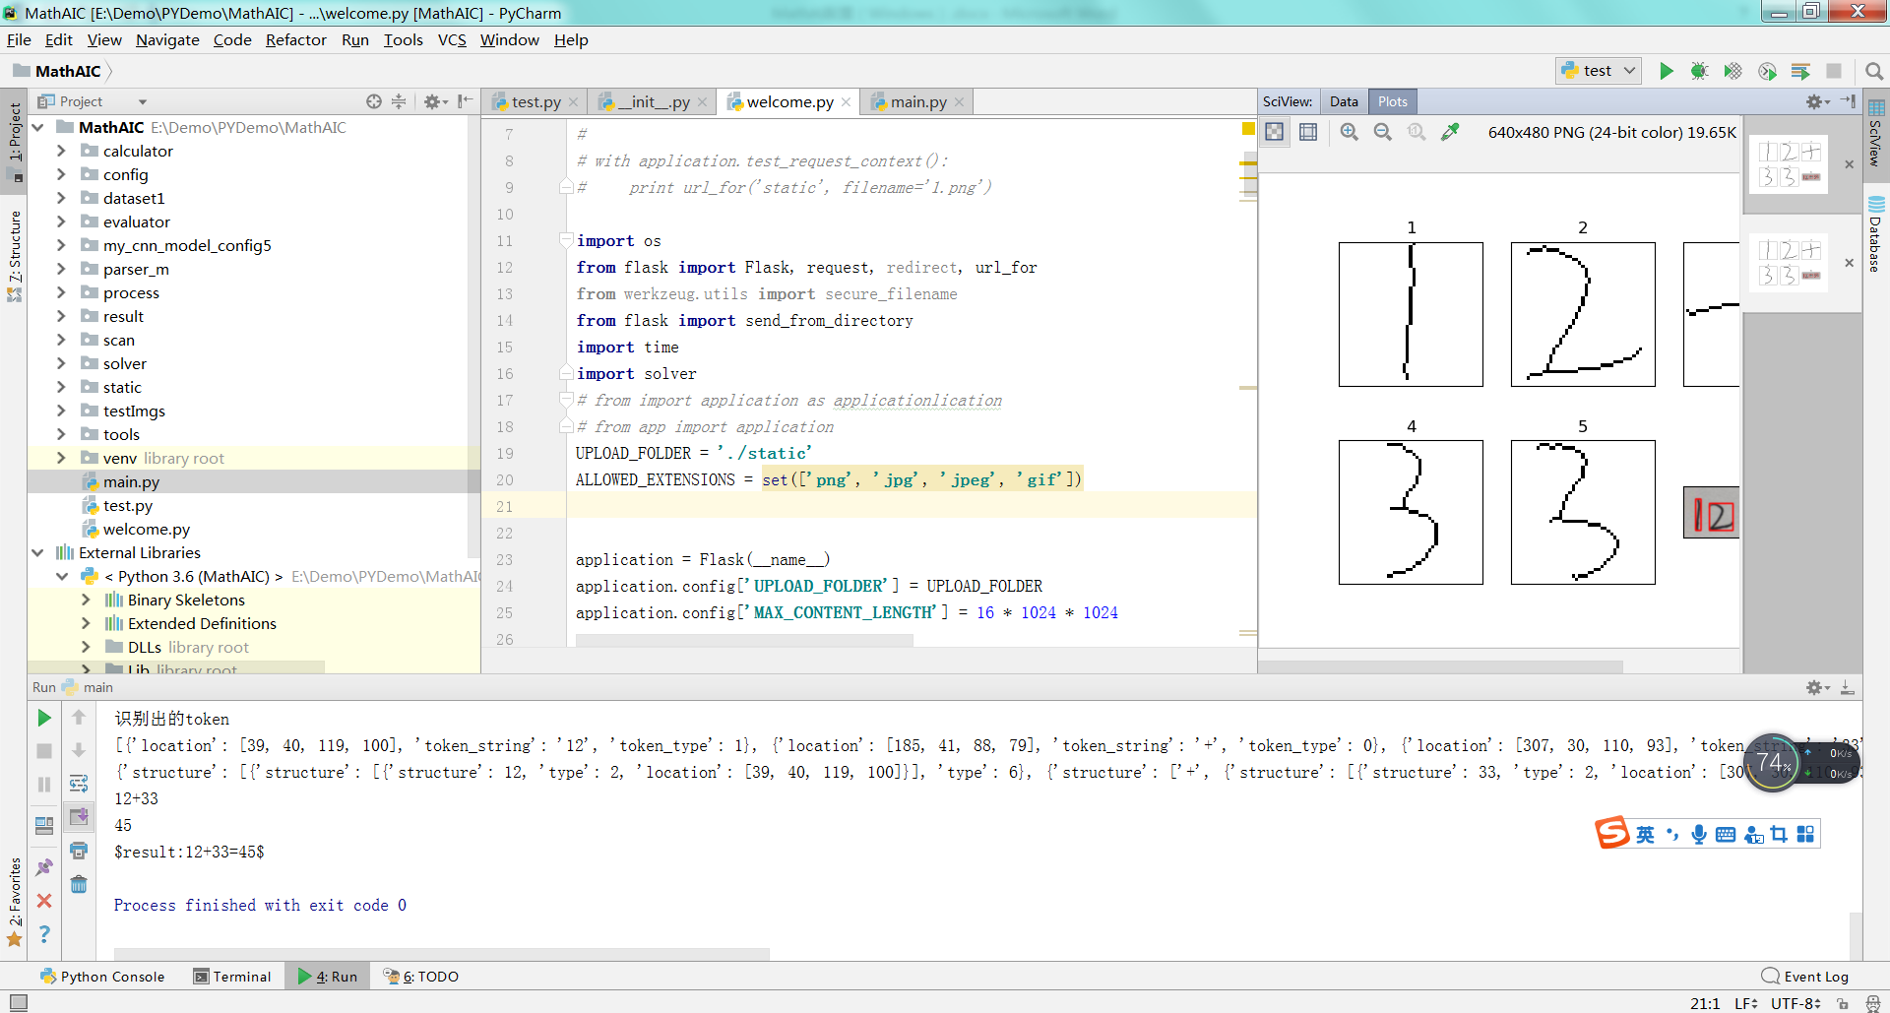

Main.py

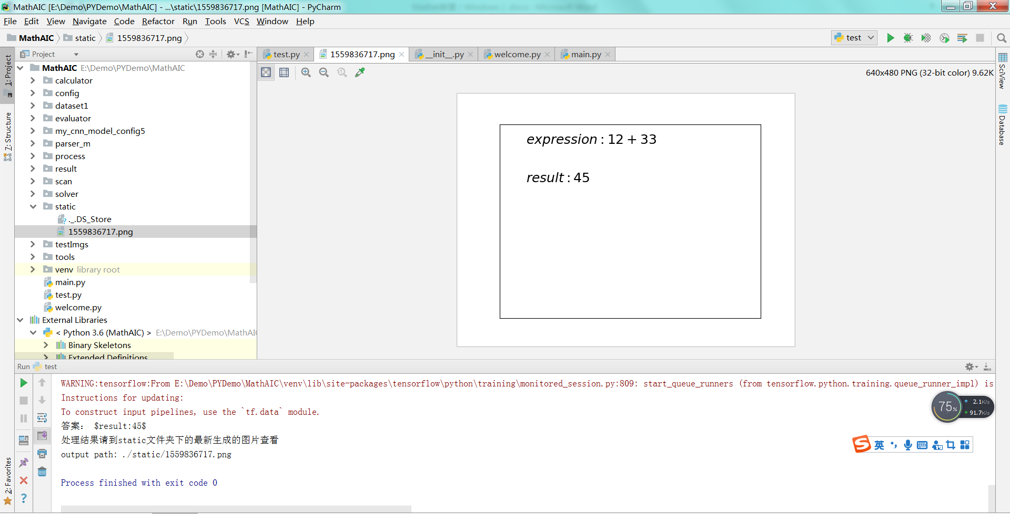

Test.py

**由于该项目属于半开源，所以在执行easy以上的计算时都会报错**